Directions: Sketch the graphs of the following functions.
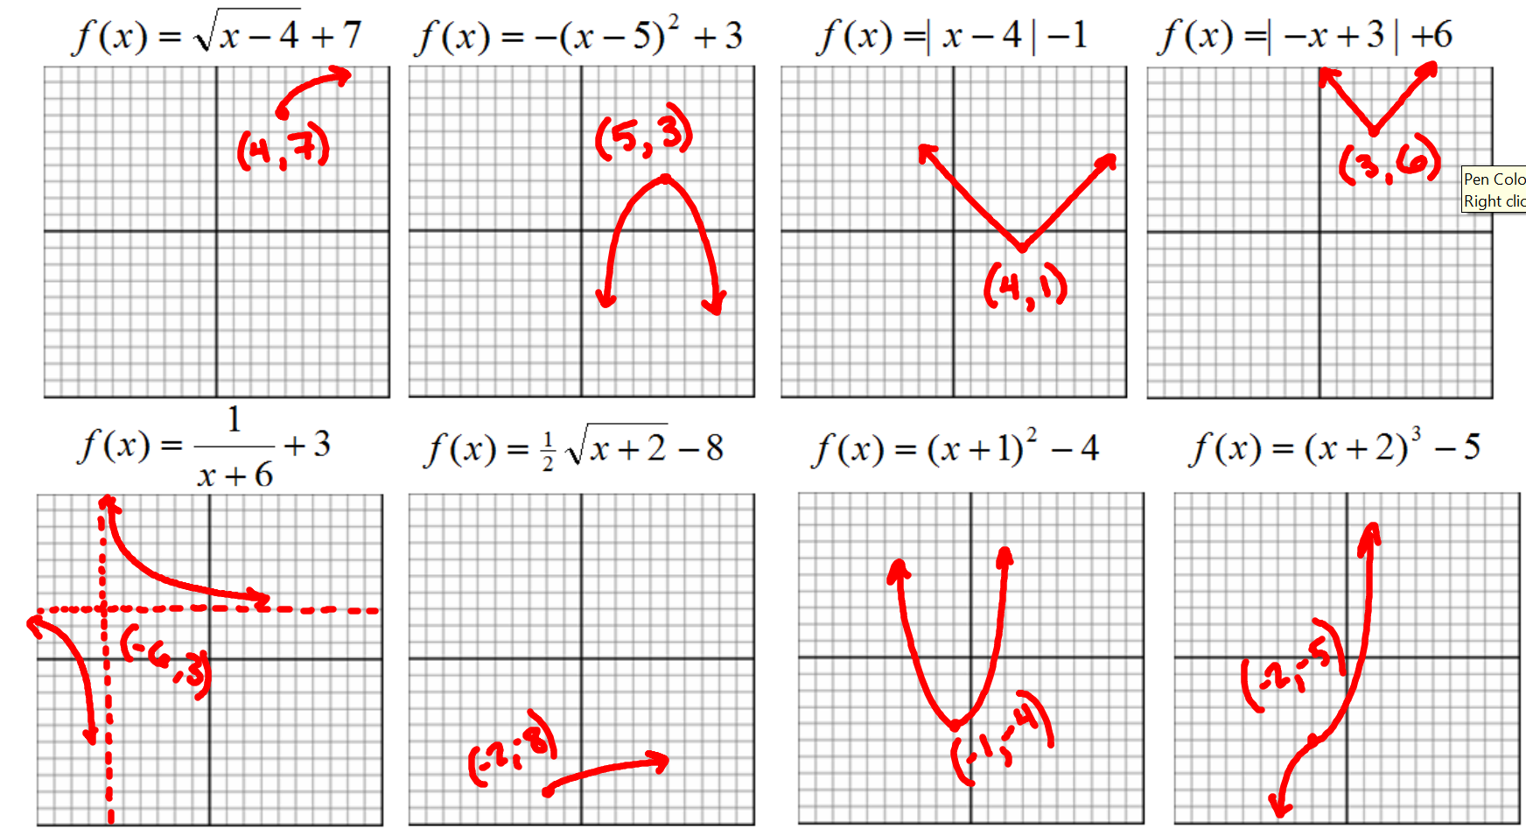

Directions: Describe (in words) the shifts and transformations of each function.

$f(x)=4|x−2|−1$$f(x)=\frac{4}{x−1}−5$

